**FYP Proposal**



Project Name

**“Student Tracking System And Online Attendance ”**

**(School Security System)**

by

**Muhammad Habib Yousuf (2016-CE-091)  
Bushra Alam (2016-CE-042)  
Shumail Javed (2016-CE-039)  
Syed Qasim Athar (2016-CE-199)**

Advised By  
**Miss Saba Ahsan**  
  
  
  
  
Submitted in partial fulfillment   
of the requirements for FYP Team  
 in the   
Department Of Computer Engineering  
Sir Syed University Of Engineering And Technology  
Date Of Submission: February 4, 2019

**Table Of Contents**

**1 INTRODUCTION**…………………………………………………………….3 **1.1 Overview**…………………………………………………………………..3 **1.2 Objectives**……………………………………………………………….....3 **1.3 Literature Survey**…………………………………………………………4**-5**

**2 METHODOLOGY**……………………………………………………………6 **2.1 Design**……………………………………………………………………....6 **2.2 Implementation**……………………………………………………………7 **2.3 Testing**……………………………………………………………………...8 **2.4 Evaluation**…………………………………………………………….……8 **3 PROJECT PLANNING**…………………………………………………..…….8 **3.1 Distribution Of Works**……………………………………..……………….8 **3.2 GANTT Chart**……………………………………………………………9 **4 Required Hardware & Software**……………………………………………….10 **4.1 Hardware**…………………………………………………………………….10 **4.2 Software**………………………………………………………………………10

**5 References**………………………………………………………………………..11

**1 Introduction**

* 1. **Overview**

Currently, low-cost Radio Frequency Identification (RFID) has been implemented widely in both industry and academic institutes as discussed where the technology was focused more efficient in terms of processing time. It saves time and money. A contactless transfer of data between the data-carrying device and its reader is far more flexible than smart card and RFID technology provides this contactless ID system solution. In the Malaysia RFID 2006-2010 Forecast and Analysis by Bizedge (2006), it is stated that the RFID spending in Malaysia is estimated to grow at a compound annual growth rate (CAGR) of 45.84% (nearly US$20.94 million (RM77 million)) in 2010 from US$2.45 million (RM9 million) in 2005. Based on the study, hardware comprises largest portion of the total commercial RFID spending in 2005 (which was 60%), driven primarily by the purchases of readers and tags, followed by software and services (40%). Knowing this, the QUICKU was developed to ease the university management team to monitor the presence of each student in the interest zone. QUICKU system contains two monitoring tasks; attendance system and tracking system using active RFID. The aim of this paper is to improve attendance data management, reduce administrative error and internal theft. This section describes briefly about the background of this study. QUICKU architecture is described in the following section. Next, analysis of QUICKU follows. Finally this paper is concluded with an outline of a future work to be carried out

* 1. **Objectives**

The goal of this project is basically try to make Students security ensure through software network by an applicant However, we’ll do it on a smaller scale and utilize legal means. Our project will mainly focus on the following objectives:

1. Develop a system that automatically track and make attendance of students through his/her chip fitted card /passcode/thumb impression

2. Build a user profile database

3. Utilize data mining techniques to find similar students according to certain personal preferences.

4. Provide a user-friendly graphical user interface to display user profiles and lists of similar students based on similar personality traits.

5. Build web based application to track attendance progress .

To achieve the first goal, we will …

To achieve the second goal, we will …

To achieve our third goal, we will …

The biggest challenge we expect to face will be … To address this challenge, we will … Also, we will

* 1. **Literature Survey**

We did an online survey and found the following systems related to our project.

* + 1. **QUICKU Architecture and Technologies**

This section explains the high-level design of QUICKU, from the RFID tag to the display data on computer screen. QUICKU comprises of two graphical user interface (GUI) which is developed for stand alone, online user and data storage; database. The conceptual design of QUICKU is illustrated in Figure. First, RFID reader detects if there is RFID tag enters its’ active range. Then, data from the RFID tag will be registered and transferred into the database through a stand alone system as the interface. A list of student will be received by the host computer and this data can be accessed directly by the university management using an online system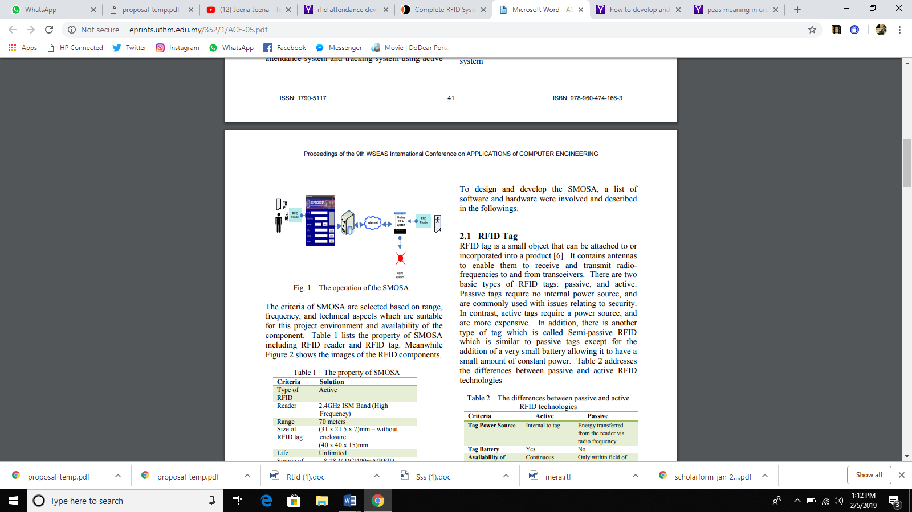

* + 1. **RFID Tag**

RFID tag is a small object that can be attached to or incorporated into a product. It contains antennas to enable them to receive and transmit radiofrequencies to and from transceivers. There are two basic types of RFID tags: passive, and active. Passive tags require no internal power source, and are commonly used with issues relating to security. In contrast, active tags require a power source, and are more expensive. In addition, there is another type of tag which is called Semi-passive RFID which is similar to passive tags except for the addition of a very small battery allowing it to have a small amount of constant power.

* + 1. **RFID Reader**

RFID reader is a device that is used to interrogate an RFID . The reader has an antenna that emits radio waves; the tag responds by sending back its data. A number of factors can affect the distance at which a tag can be read (the read range). The frequency used for identification, the antenna gain, the orientation and polarization of the reader antenna and the transponder antenna, as well as the placement of the tag on the object to be identified will all have an impact on the RFID system’s read range

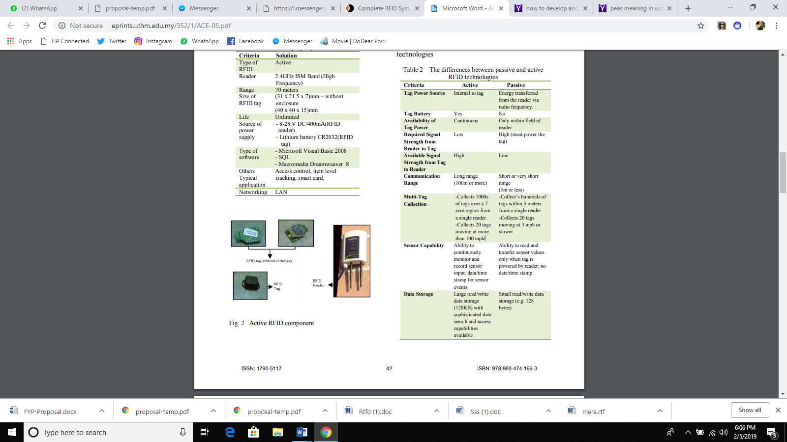

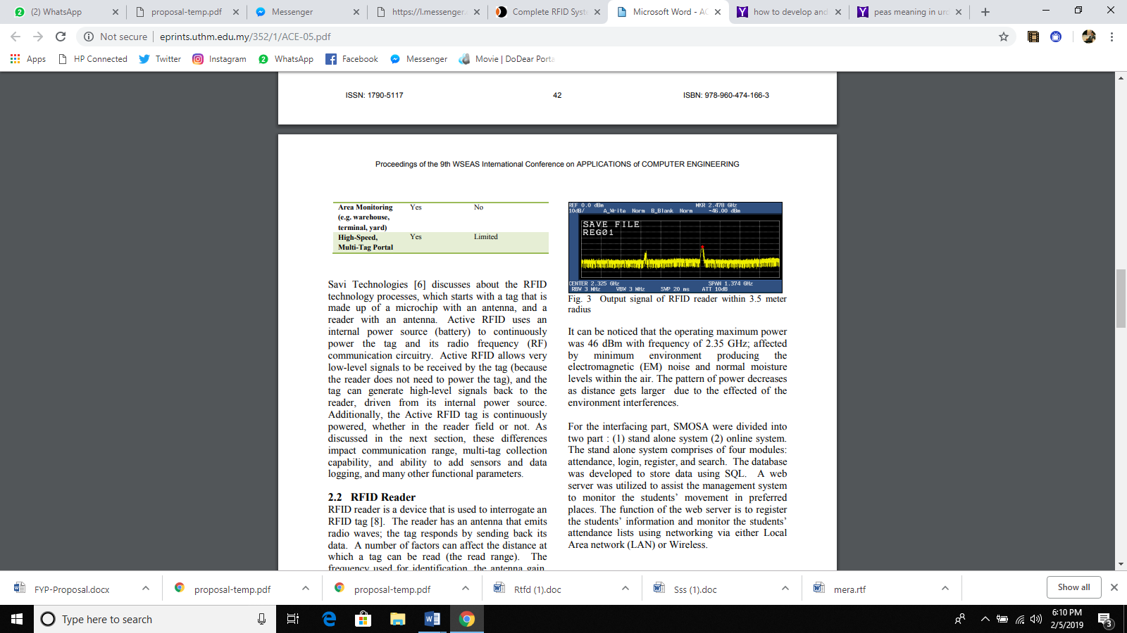

1. **Methodology**
   1. **Design**

An experiment has been conducted to test the functionality and performances of QUICKU; a spectrum analyzer was used to capture the output for the RFID tag.. Hardware analysis obtained from the experiment. An experiment was conducted in order to test the functionality and performances of the QUICKU with minimum disturbance of people and electronic appliances.

* 1. **Database Design**

The database has three tables that are attendance, registration and users. The detailed information in every table

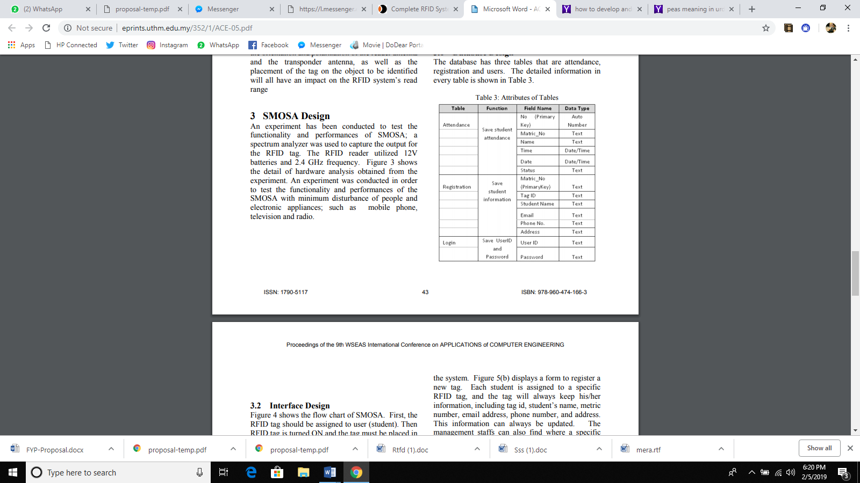

* 1. **Interface and Design**

The flow chart of QUICKU. First, the RFID tag should be assigned to user (student). Then RFID tag is turned ON and the tag must be placed in a reading range. The antenna will generate the radio frequency field to the tag. Then, RFID will be detected after the reader receives signals from the tag and uses to record attendance and saves it in the database or to search student’s details in the database. Although these steps sound simple but the most important key is to register the tag first. Secondly if problems still occur, some maintenance work would be required to identify the status of the tag and the reader. This process will repeat if a student with a tag enters the antenna reader region.

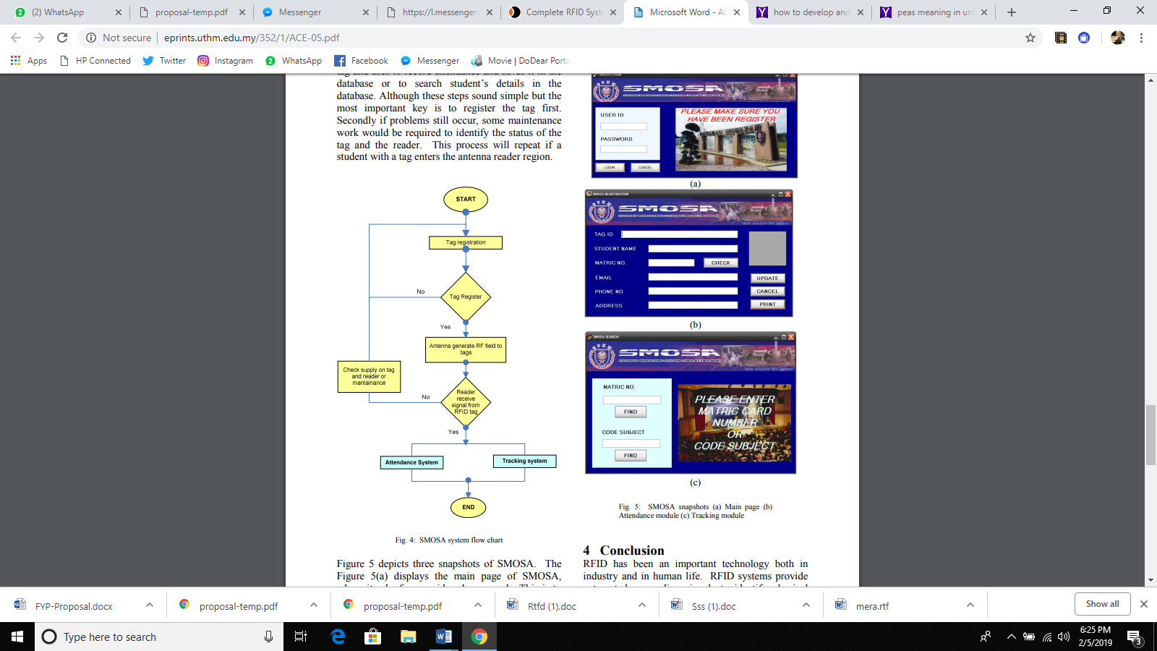

* 1. **Implementation**

The Implementation phase will include the following aspects that are discussed below:

* 1. **Built The User Interface**In this, we can recognize text through image processing. And then after this searching takes place with the help Graphical User Interface.(Android Studio)

* 1. **Testing**

During the development process, testing will be done to ensure all modules are built correctly. Application integration testing has been done after we have built all elements and then it combined into the application.

* 1. **Evaluation**

After we have done all the testing , we will evaluate the application to check whether it fulfills our aim or not. If it fulfills well then we directly go through the next stage. If it is not fulfills then we can scrutinize it out.

1. **Project planning**
   1. **Distribution of work**

|  |  |  |  |  |
| --- | --- | --- | --- | --- |
| **Task** | **Habib** | **Bushra** | **Shumail** | **Qasim** |
| Do the literature |  |  |  |  |
| Analyze Social Networks |  |  |  |  |
| Design Data Crawling Techniques |  |  |  |  |
| Design Data Mining Algorithms |  |  |  |  |
| Design the User Interface |  |  |  |  |
| Develop the Data Crawler |  |  |  |  |
| Build the Data base |  |  |  |  |
| Develop the Data mining Algorithms |  |  |  |  |
| Build the User Interface |  |  |  |  |
| Test the Web Crawler |  |  |  |  |
| Test the Database |  |  |  |  |
| Test the Data mining Algorithms |  |  |  |  |
| Test the User Interface |  |  |  |  |
| Perform Integration Testing |  |  |  |  |
| Write the Perposal |  |  |  |  |
| Write the Monthly Reports |  |  |  |  |
| Write the Progress Reports |  |  |  |  |
| Write the Final Report |  |  |  |  |
| Prepare for the Presentation |  |  |  |  |
| Design the Project Poster |  |  |  |  |

* 1. **GANTT Chart**

|  |  |  |  |  |  |  |  |  |  |  |  |  |  |  |  |  |  |  |  |  |  |  |  |  |  |  |  |  |  |  |  |  |  |  |  |  |  |  |  |  |
| --- | --- | --- | --- | --- | --- | --- | --- | --- | --- | --- | --- | --- | --- | --- | --- | --- | --- | --- | --- | --- | --- | --- | --- | --- | --- | --- | --- | --- | --- | --- | --- | --- | --- | --- | --- | --- | --- | --- | --- | --- |
| TASK | FEB | | | | MARCH | | | | APRIL | | | | MAY | | | | JUN | | | | JULY | | | | AUG | | | | SEP | | | | OCT | | | | NOV | | | |
| Literature Survey | 1 | 2 | 3 | 4 | 1 | 2 | 3 | 4 | 1 | 2 | 3 | 4 | 1 | 2 | 3 | 4 | 1 | 2 | 3 | 4 | 1 | 2 | 3 | 4 | 1 | 2 | 3 | 4 | 1 | 2 | 3 | 4 | 1 | 2 | 3 | 4 | 1 | 2 | 3 | 4 |
|  |  |  |  |  |  |  |  |  |  |  |  |  |  |  |  |  |  |  |  |  |  |  |  |  |  |  |  |  |  |  |  |  |  |  |  |  |  |  |  |
| Design Database |  |  |  |  |  |  |  |  |  |  |  |  |  |  |  |  |  |  |  |  |  |  |  |  |  |  |  |  |  |  |  |  |  |  |  |  |  |  |  |  |
| Design Data Queries |  |  |  |  |  |  |  |  |  |  |  |  |  |  |  |  |  |  |  |  |  |  |  |  |  |  |  |  |  |  |  |  |  |  |  |  |  |  |  |  |
| Design User interface |  |  |  |  |  |  |  |  |  |  |  |  |  |  |  |  |  |  |  |  |  |  |  |  |  |  |  |  |  |  |  |  |  |  |  |  |  |  |  |  |
| Built Database |  |  |  |  |  |  |  |  |  |  |  |  |  |  |  |  |  |  |  |  |  |  |  |  |  |  |  |  |  |  |  |  |  |  |  |  |  |  |  |  |
| Develop Queries |  |  |  |  |  |  |  |  |  |  |  |  |  |  |  |  |  |  |  |  |  |  |  |  |  |  |  |  |  |  |  |  |  |  |  |  |  |  |  |  |
| Built User Interface |  |  |  |  |  |  |  |  |  |  |  |  |  |  |  |  |  |  |  |  |  |  |  |  |  |  |  |  |  |  |  |  |  |  |  |  |  |  |  |  |
| Test The Database |  |  |  |  |  |  |  |  |  |  |  |  |  |  |  |  |  |  |  |  |  |  |  |  |  |  |  |  |  |  |  |  |  |  |  |  |  |  |  |  |
| Test The Queries |  |  |  |  |  |  |  |  |  |  |  |  |  |  |  |  |  |  |  |  |  |  |  |  |  |  |  |  |  |  |  |  |  |  |  |  |  |  |  |  |
| Test The User Interface |  |  |  |  |  |  |  |  |  |  |  |  |  |  |  |  |  |  |  |  |  |  |  |  |  |  |  |  |  |  |  |  |  |  |  |  |  |  |  |  |
| Perform Integration Testing |  |  |  |  |  |  |  |  |  |  |  |  |  |  |  |  |  |  |  |  |  |  |  |  |  |  |  |  |  |  |  |  |  |  |  |  |  |  |  |  |
| Write The Proposal |  |  |  |  |  |  |  |  |  |  |  |  |  |  |  |  |  |  |  |  |  |  |  |  |  |  |  |  |  |  |  |  |  |  |  |  |  |  |  |  |
| Write The Monthly Report |  |  |  |  |  |  |  |  |  |  |  |  |  |  |  |  |  |  |  |  |  |  |  |  |  |  |  |  |  |  |  |  |  |  |  |  |  |  |  |  |
| Write The Progress Report |  |  |  |  |  |  |  |  |  |  |  |  |  |  |  |  |  |  |  |  |  |  |  |  |  |  |  |  |  |  |  |  |  |  |  |  |  |  |  |  |
| Write The Final Report |  |  |  |  |  |  |  |  |  |  |  |  |  |  |  |  |  |  |  |  |  |  |  |  |  |  |  |  |  |  |  |  |  |  |  |  |  |  |  |  |
| Prepare For The Presentation |  |  |  |  |  |  |  |  |  |  |  |  |  |  |  |  |  |  |  |  |  |  |  |  |  |  |  |  |  |  |  |  |  |  |  |  |  |  |  |  |
| Design The Project Poster |  |  |  |  |  |  |  |  |  |  |  |  |  |  |  |  |  |  |  |  |  |  |  |  |  |  |  |  |  |  |  |  |  |  |  |  |  |  |  |  |

1. **Required hardware and software**
   1. **Hardware**

The criteria of QUICKU are selected based on range, frequency, and technical aspects which are suitable for this project environment and availability of the component. lists the property of QUICKU including RFID reader and RFID tag. The images of the RFID components.

i3 Processor Based Computer

1 GB RAM

50 GB Hard Disk

Monitor

Internet Connection

Mobile Hardware

RFID Hardware

* 1. **Software**

Visual Studio.

ASP.Net

SQL Server .(for Database)

1. **Reference**

This is the line of thought that governs Sri Technologies’ RFID Smart Attendance System. At the outset, our attendance systems are devices that automatically mark student attendance. As an advanced feature, the attendance record of the student is also show to his or her parents, using a simple mix of GPRS and SMS

LINK 1

http://r.search.yahoo.com/_ylt=AwrgEY.Dl1lcEhUAXbMPxQt.;_ylu=X3oDMTByb2lvbXVuBGNvbG8DZ3ExBHBvcwMxBHZ0aWQDBHNlYwNzcg--

LINK 2

http://ieeexplore.ieee.org/http://r.search.yahoo.com/RV=2/RE=1549404164/RO=10/RU=http%3a%2f%2fsmartattendancesystem.com%2f/RK=2/RS=1e9BW23.N7RkO7S8.T7VH_T..CU-